ABOUT THE PROPOSAL

OTP’s Project Proposals provides a platform for individuals, artists & OTP community members, like you, who have a great idea for our next series and want to start to explore its potential with OTP. We will be accepting any proposal that can be produced through a theatrical lens and aligns with our mission and community.

We ask that each proposal be submitted with a champion(s) behind it. This person will ‘champion’ the success of the project as it proceeds through our development process. They will turn the strategy of this proposal into action on our stage with OTP’s Board and Staff. The proposal itself covers every pillar of a successful project at OTP and we provide a collaborative application process to make sure the idea is given it’s best chance.

While we can’t move forward with every proposal, we do look forward to finding ways to work with those who shares their art with us and there will be many opportunities created from the ideas we move forward with.

PREVIOUS PROJECTS

LOVE OF THE NIGHTENGALE | 2015
By Timberlake Wertenbacher
Submitted by Jessica Ernst

MURPH | 2016
by Catherine O’Neill
Submitted by Dave DiLillo & Catherine O’Neill
FEAR PROJECT | 2017
An OTP Devised Production
Submitted by Lynda Bachman & Molly Gilbert

GAY SHORTS | 2017
By George Smart
Submitted by George Smart | 2017
AN EDUCATION IN PRUDENCE | 2018
by Stefan Lanfer
Submitted by George Smart

GAY SHORTS : We Are Family | 2018
By George Smart
Submitted by George Smart

OUR SELECTION PROCESS

OTP’s Board of Directors will be accepting these proposals through 2018. The OTP Board will begin to set up a series of follow up events based on interest. These follow up events may include a meeting with the Project Champions, a reading of the script / score, or other elements that help us get a complete look at the scope of work. Once we have properly vetted the proposal itself and completed any follow up events, the OTP Board will meet to discuss and vote on the projects inclusion in Series 5.

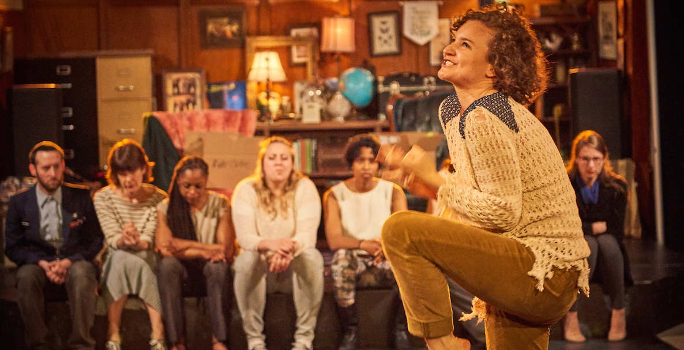

OTP’s Fear Project | 2017

OPEN THEATRE PROJECT’s MISSION

Open Theatre Project was formed to transform lives and build thriving communities through high-quality theatrical experiences. We are dedicated to providing artistic opportunities which allow the expression of diverse ideas to traditional and non-traditional audiences.

Our work is defined by the passion of individual artists in partnership with the culture of professionalism and collaboration we build around each of our creative endeavors.

We welcome all backgrounds, skill levels, and perspectives in order to broaden voices in theater with a particular focus on developing opportunities for women, people of color, LGBTQ and the elderly.

HOW TO APPLY

- Fill out our 2018 Project Proposal attached HERE
- Please submit Project Proposal and all relevant information to dustin@theopentheatre.com
- Please include 2018 Project Proposal - YOUR NAME / PROJECT NAME in the subject line

If you have any questions please don’t hesitate to reach out!

Thank you for your interest in working with Open Theatre Project.

APPLICATION

ABOUT THE PROJECT

NAME :
SHORT DESCRIPTION :
EXTENDED
DESCRIPTION :
TYPE OF EVENT :
WHY THIS PROJECT? Aka Project Mission Statement:

ABOUT YOU

PROJECT CHAMPION(S) :
PRIMARY CONTACT :
EMAIL :
PHONE :

SCHEDULE

PLANNING TIME :
REHEARSAL PERIOD :
# OF PERFORMANCES :
ON GOING? :

PRODUCTION NEEDS

HOUSE SIZE :
LOCATION TYPE :
IDEAL LOCATION :
NEEDED AMENETIES :
STAFFING
Describe the team needed to execute the project. This includes directors, actors, management, marketing and more.

TECHNICAL ELEMENTS
Describe any technical needs for the event including scenic, lighting, costumes, props and more.

FINANCIALS

BUDGET
Include basic details and amounts for an initial budget. See basic production budget model attached.

ESTIMATED TOTAL COST | $
FUNDRAISING IDEAS
What ways would you imagine raising money to support this who.

FUNDRAISING IDEAS
What ways would you imagine raising money to support this who.

GRANTS
Are you aware of any grants or giving opportunities?

AUDIENCE

DESCRIBE YOUR
IDEAL AUDIENCE

HOW DOES THIS PROJECT FIT INTO THE JAMAICA PLAIN COMMUNITY?
HOW DOES THIS PROJECT REFLECT OTP’S MISSION?

MARKETING / OUTREACH

MAREKETING PLAN
Give us an idea of how you plan to get the word out along with the people and resources you need to get it done right.

OUT REACH OPPORTUNITIES
Our mission means creating opportunities for our community at large. How does this project support that and put its ideas out there in a larger way?

OTHER

WHAT ELSE?
Here is your chance to give us any other information you think we need to really get behind this idea

